Saturday 4th Sep  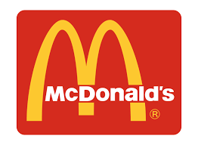  Mcdonalds & Park  £6.00 | Saturday 11th Sep  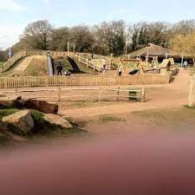  Countryside Centre | Saturday 18th Sep  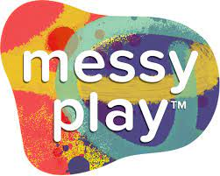  £1.00 | Saturday 25th Sep  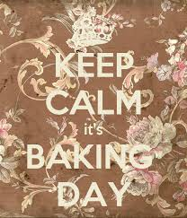  Baking Day  £3.00

