Saturday 6th July  TENNIS £10 | Saturday 13th July  £2 | Saturday 20st July  HOT TUB PARTY  £3 | Saturday 27th July  £8
Saturday 3RD Aug  BREAD MAKING  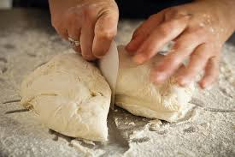  £2 | Saturday 10th Aug  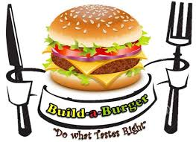  £2 | Saturday 17th Aug  £2 | Saturday 24th Aug  TENNIS £10
Saturday 7th Sep  TENNIS £10 | Saturday 14th Sep  £2 | Saturday 21st Sep  £3 | Saturday 28th Sep  