Saturday ^{3rd} July  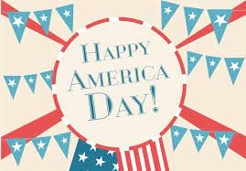  America Day  £1 | Saturday 10th July  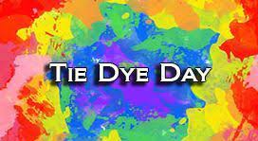  Tye Dye Day  £3 | Saturday 17th July  Picnic in the Park | Saturday 24th July  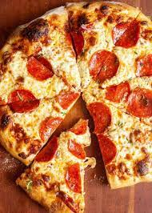  Pizza Day  £5 | Saturday 31st July  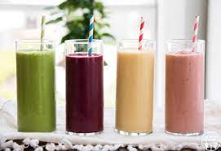  Smoothie Making Day  £2
Saturday 7th Aug  Pamper Day | Saturday 14th Aug  Music Day | Saturday 21st Aug | Saturday 28th Aug  