All ACTIVITY DATES FOR SATURDAYS JULY

Saturday 1st July  Africa Day  £1 per child  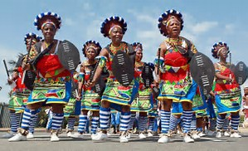 | Saturday 8th July  Pizza Making  £2 per child | Saturday 15th July  Park & Picnic  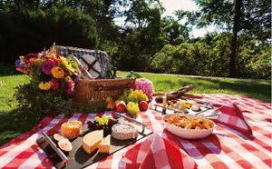 | Saturday 22nd July  Tennis  £8 per child
Saturday 24th June
Cooking
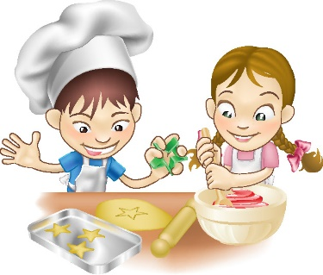
£1

