NEW HOPE EASTER HOLIDAYS 2018

Tue 3rd April  SWIMMING  £8 | Wed 4th April  TIE DYE GIFT MAKING  £2.50 | Thur 5th April  CATCH THE COWBOY | Fri 6th April  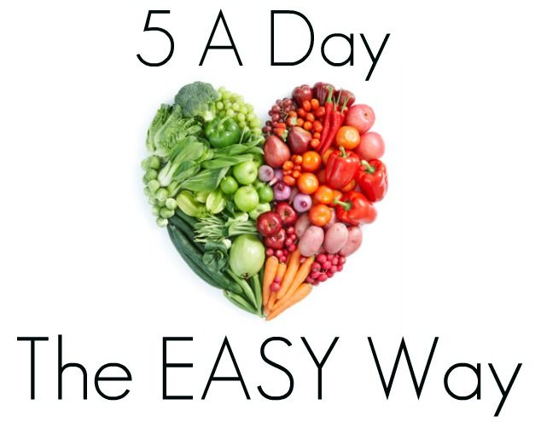  VEGGIE & FRUIT DAY
Mon 9th April  FUN WITH FRIENDS  £8 PER CHILD | Tue 10th April  £8 PER CHILD | Wed 11th April | Thur 12th april  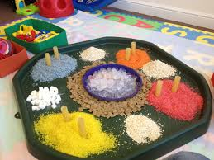  MESSY PLAY
Fri 13th April

