NEW HOPE PLANNERS WHITSON WEEK 2021

TUESDAY 1st june  HOT TUB PARTY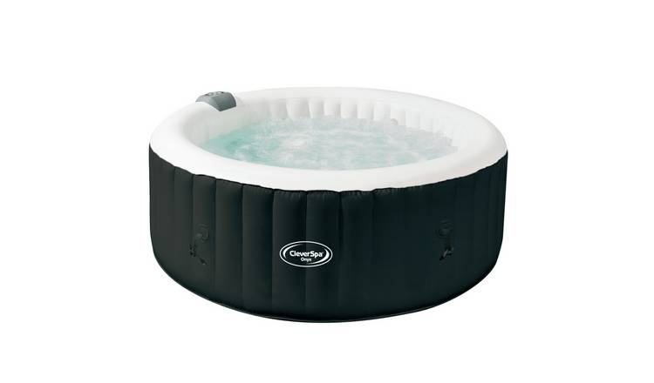 | WEDNESDAY 2nd june  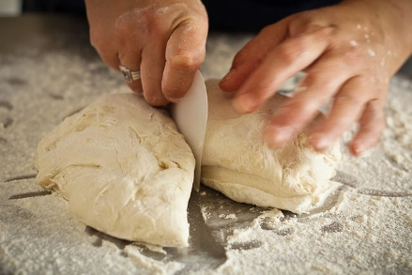  BREAD MAKING  £2 | THURSDAY 3rd june  £2 | FRIDAY 4th june  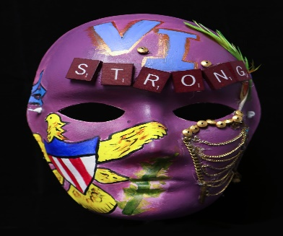  MASK MAKING  £3

