logo.gif

**To book your child’s place please send your preferred dates by email on Saturday @ 2pm For enquires** jean.wilson46@yahoo.co.uk **or phone 01905 355295**

**Jean – 01905 355295**

**MONDAY 24TH JULY**



**THURSDAY 27RD JULY**



**Messy Play**

**TUESDAY 25ST JULY**

**Juggling Jim**

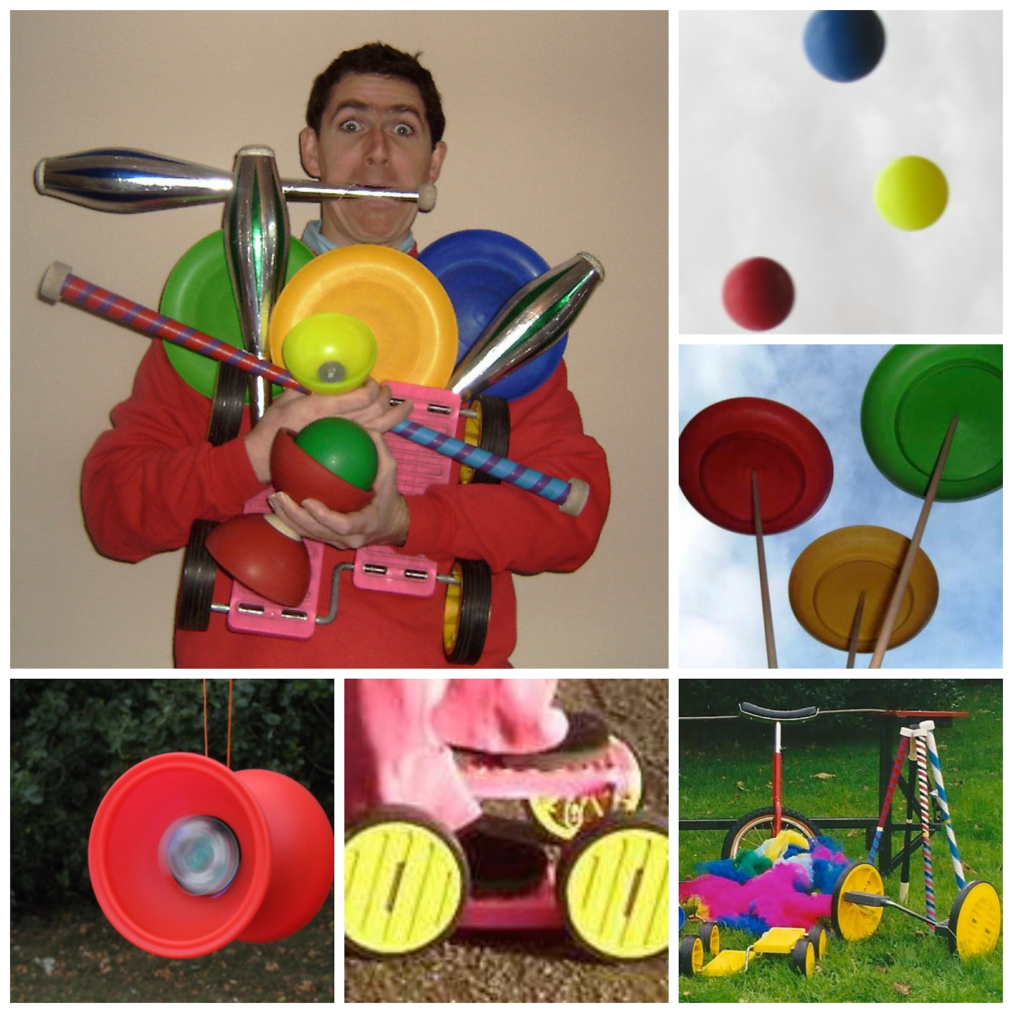

**FRIDAY 28th JULY**



**RAGLEY HALL £20**

***Maximum of £10 spending money***

**WEDNESDAY 26ND JULY**



**SPORTS DAY**

**SATURDAY 29th JULY**



**JUNK MODELLING**

logo.gif

**To book your child’s place please send your preferred dates by email on Saturday @ 2pm** [jean.wilson46@yahoo.co.uk](mailto:jean.wilson46@yahoo.co.uk) **or phone**

**Jean – 01905 355295**

**MONDAY 31th JULY**



**SCIENCE DAY £1.50**

**THURSDAY 3rd AUGUST**

**£3**



**TUESDAY 1st AUGUST**



**HYDROTHERAPY £8**

**FRIDAY 4TH AUGUST**



**WEDNESDAY 2nd AUGUST**



**AROUND THE WORLD FOOD DAY**

**SATURDAY 5TH AUGUST**



**TEDDY BEAR’S PICNIC**

logo.gif

**To book your child’s place please send your preferred dates by email on Saturday @ 2pm** [jean.wilson46@yahoo.co.uk](mailto:jean.wilson46@yahoo.co.uk) **or phone**

**Jean – 01905 355295**

**MONDAY 7TH AUGUST**



**PIZZA PASTA DAY**

**THURSDAY 10th AUGUST**



**CINEMA - £7**

***Maximum of £5 spending money***

**TUESDAY 8th AUGUST**



**HYDROTHERAPY £8**

**FRIDAY 11th AUGUST**



**Ray’s farm £20**

***Maximum of £10 spending money***

**WEDNESDAY 9th AUGUST**



**BEACH DAY**

**SATURDAY 12th AUGUST**



**McDonald’s & Park £6**

logo.gif

**To book your child’s place please send your preferred dates by email on Saturday @ 2pm** [jean.wilson46@yahoo.co.uk](mailto:jean.wilson46@yahoo.co.uk) **or phone**

**Jean – 01905 355295**

**MONDAY 14th AUGUST**



**ANIMAL MANIA £8**

**THURSDAY 17th AUGUST**



**New hope bake off! £1.50**

**TUESDAY 15th AUGUST**



**HYDROTHERAPY £8**

**FRIDAY 18th AUGUST**



**Caribbean day**

**WEDNESDAY 16th AUGUST**



**BOWLING £6**

***Maximum of £5 spending money***

**SATURDAY 19th AUGUST**



**American day**

logo.gif

**To book your child’s place please you’re your preferred dates by email on Saturday @ 2pm** [jean.wilson46@yahoo.co.uk](mailto:jean.wilson46@yahoo.co.uk) **or phone**

**Jean – 01905 355295**

**MONDAY 21ST AUGUST**

**TAEKWOMDO**



**THURSDAY 24TH AUGUST**



**GIANT collage day £1**

**TUESDAY 22ND AUGUST**



**HYDROTHERAPY £8**

**FRIDAY 25ST AUGUST**



**MESSY PLAY**

**WEDNESDAY 23RD AUGUST**

**£3**



**SATURDAY 26ND AUGUST**



**CHOCOLATE DAY**

logo.gif

**To book your child’s place please send your preferred dates by email on Saturday @ 2pm** [jean.wilson46@yahoo.co.uk](mailto:jean.wilson46@yahoo.co.uk) **or phone**

**Jean – 01905 355295**

**MONDAY 28th AUGUST**



**CLOSED**

**THURSDAY 31ST AUGUST**



**GARDENING DAY**

**TUESDAY 29th AUGUST**



**TRESURE HUNT**

**FRIDAY 1ST SEPTEMBER**



**PUPPET MAKING**

**WEDNESDAY 30th AUGUST**



**CLAY MODELLING**

**SATURDAY 2ND SEPTEMBER**



**END OF SUMMER PARTY £3**