SUMMER HOLIDAY’S CLUB 2018

 | Thursday ^{1st} Aug  GARDENING DAY £3 | Friday 2rd Aug  £2
Monday 5th Aug  £20 PER CHILD | Tuesday 6th Aug  Swimming £10 | Wednesday 7th Aug  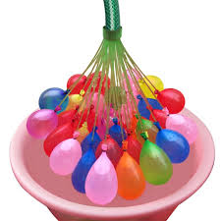  WATER BOMB FUN  £2 | Thursday 8th Aug  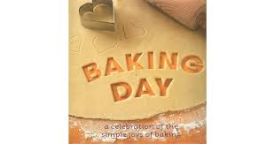  £2 | Friday 9th Aug  £20
Monday 12th Aug  £15 | Tuesday 13th Aug  Swimming £10 | Wednesday 14th Aug | Thursday 15th Aug  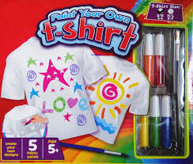  MAKE YOUR OWN T SHIRT  £3 | Friday 16th Aug  TREASURE HUNT  £2
Monday 19th Aug  BOWLING  £10 | Tuesday 20nd Aug  Swimming £10 | Wednesday 21st Aug  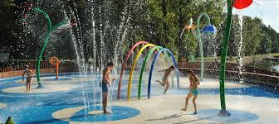  SPLASH PAD  £8 | Thursday 22nd Aug  £2 | Friday 23rd Aug  £2
Monday 26th Aug  CLOSED | Tuesday 27th Aug  CLOSED | Wednesday 28th Aug  TYE DYE DAY £3 | Thursday 29th Aug  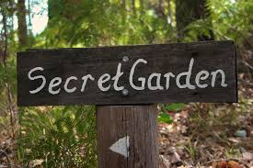  £3 | Friday 30TH Aug  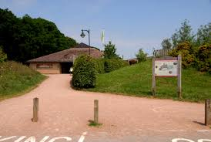  COUNTRY SIDE CENTRE £2

SATURDAY 31ST AUG END OF SUMMER PARTY !!!!!!!
£10 SLIME MAKING FACTORY AND BBQ
