SUMMER HOLIDAY’S CLUB 2021

Monday 26th July  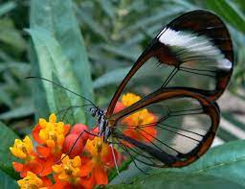  Watch Our Butterfly’s Grown | Tuesday 27th July  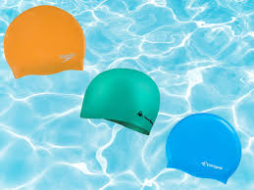  Snooze Swimming £10 | Wednesday 28th July  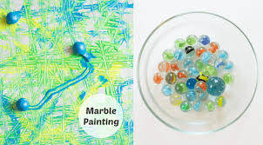  Marble painting  £3 | Thursday 29th July  Hand painting £3 | Friday 30th July  Space Day
Monday 2nd Aug  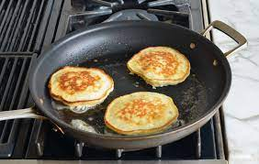  PanCake Making  £2 | Tuesday 3rd Aug  Decorating Slippers  £3 | Wednesday 4th Aug | Thursday 5th Aug  Cup cake Day  £2 | Friday 6th Aug  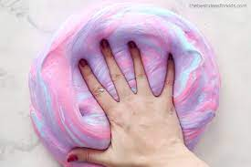  Slime Making Day  £2
Monday 9th Aug  Pamper Day | Tuesday 10th Aug | Wednesday 11th Aug  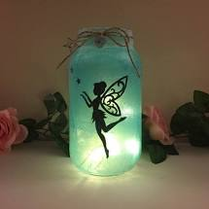  Fairy Dream Jars £3 | Thursday 12th Aug  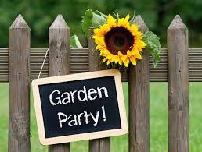 | Friday 13th Aug  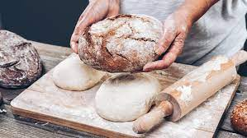  Bread Making  £2
Monday 16th Aug  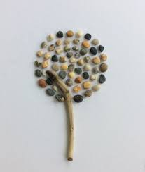  Pebble Art £2 | Tuesday 17th Aug  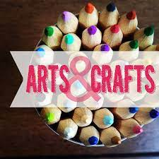 | Wednesday 18th Aug  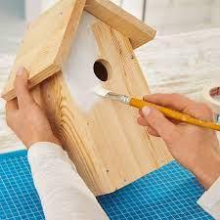  Bird Box Painting  £3 | Thursday 19th Aug  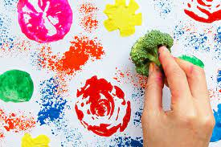  Veg Art | Friday 20th Aug  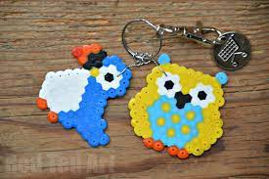  Key Ring Making  £3
Monday 23rd Aug  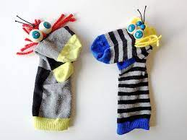  Sock Puppet Making | Tuesday 24th Aug  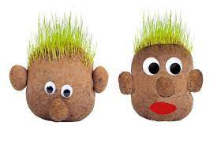Mr & Mrs Grass Heads | Wednesday 25t^{h} Aug  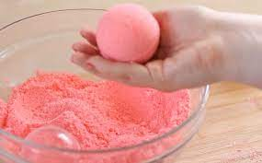  Bath Bomb Making £3 | Thursday 26th Aug  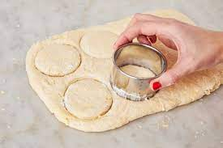  Biscuit Making  £2 | Friday 27th Aug  £1

