OCTOBER SATURDAYS 2018

Saturday 6th Oct  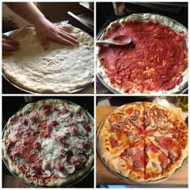  PIZZA MAKING  £1.50 | Saturday 13th Oct  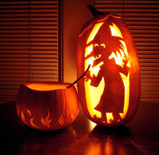  PUMPKIN CARVING  £1.50 | Saturday 20th Oct    TENNIS  £8 | Saturday 27th Oct  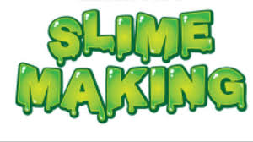  MAKE YOU OWN SLIME  £3

