MON 25TH Oct  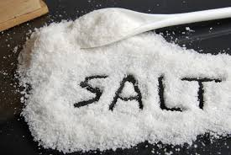  Salt Dough Day | TUE 26th Oct  Tye Dye Day  £3 | WED 27th Oct  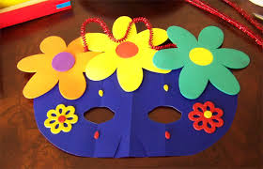  Mask Making  £1 | THUR 28T^{h} Oct  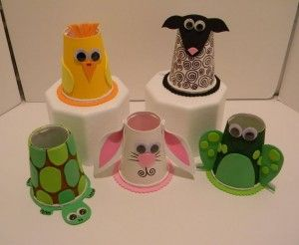  Paper Cup Art
FRI 29th Oct
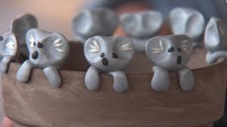
Clay Modeling
£3

