NEW HOPE SATURDAY PLANNERS MAY 2021

Saturday 1st  May  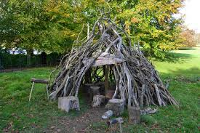  Den making  £3 | Saturday 8th  May  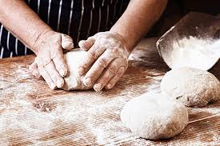  Bread making  £3 | Saturday 15th  May  £5(uber) | Saturday 22nd  May  Water play
Saturday 29th may
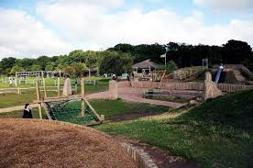county hall woods

