NEW HOPE SATURDAY PLANNERS MAY/JUNE 2018

Saturday 5th May  COUNTRY &  WESTERN DAY | Saturday 12th May  SPORTS DAY | Saturday 19th May  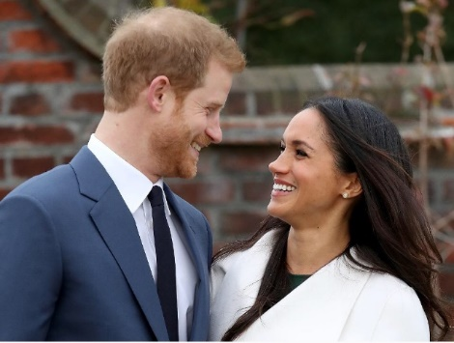  ROYAL WEDDING DAY | Saturday 26th May  LET’S SAVE THE WORLD
SATURDAY 2ND JUNE  TEN PIN BOWLING £8 | SATURDAY 9TH JUNE  SPORT’S DAY | SATURDAY 16TH JUNE  FATHERS DAY | SATURDAY 23RD JUNE  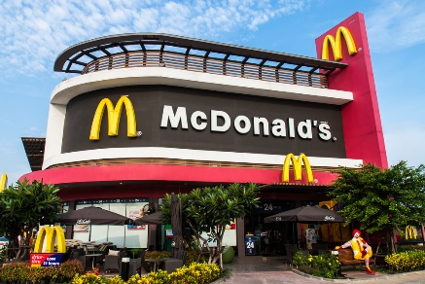  MCDONALDS £7
SATURDAY 30RD JUNE
VIKING DAY

