NEW HOPE SATURDAY PLANNERS JUNE 2021

SATURDAY 5^{H} JUNE  SCIENCE DAY  £3 | SATURDAY 12TH JUNE  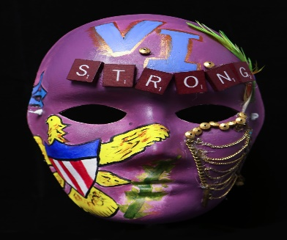  MASK MAKING  £2 | SATURDAY 19TH JUNE  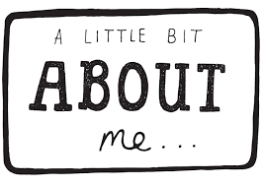 | SATURDAY 26TH JUNE

