DECEMBER CHRISTMAS WEEK TWO 2021

Wednesday 29th Dec    Messy Play  £2.00 | Thursday 30th Dec  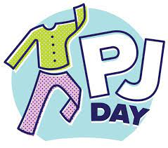 | Friday 31st Dec  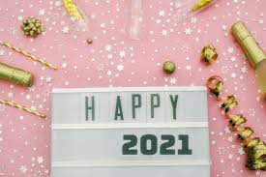  New Years Party  £2.00

