CHRISTMAS HOLIDAYS WEEK ONE

Monday 20rd DEC  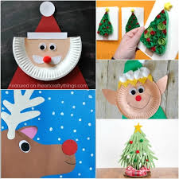  Christmas Crafts £1 | Tuesday 21st Dec  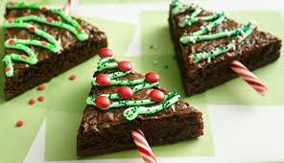  Christmas Baking £2.00 | Wednesday 22nd Dec   | Thursday 23rd Dec    Father Christmas Visit

