NEW HOPE APRIL SATURDAY PLANNER 2021

Saturday 3thApril  £2.00 | Saturday 10th April  Cupcake day  £2 | Saturday 17st April  DEN MAKING  £3.50 | Saturday 24th April  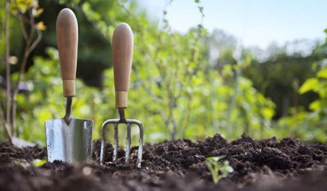  Gardening day  £3

