NEW HOPE APRIL SATURDAY PLANNER 2018

Saturday 7th April  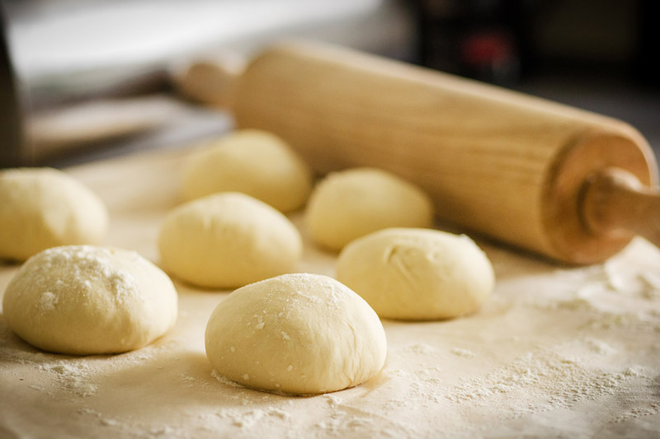  PIZZA MAKING  £1 PER CHILD | Saturday 14th April  GARDENING DAY  £1.50 PER CHILD | Saturday 21st April  SMOOTHIE MAKING  £1 PER CHILD | Saturday 28th April  EXCITING DAY TRIP  £15 PER CHILD
SATURDAY 30RD JUNE
VIKING DAY

